Objective Questions:

1)What is the total no. of tables present in the data?
Ans: 2
Dataset is organized into two distinct tables, containing following worksheets:
- Raw Data
- Country Description

2)What is the total no. of attributes present in the data?
Ans: 22
A total of 22 distinct attributes are present across dataset, representing various aspects of restaurant data.
3)How many categorical columns are there in the data? [Search about categorical and continuous data, and try to answer this question]
Ans: Categorical columns:13,
Columns are:
1.Country Name
2.Price_range
3. Switch_to_order_menu
4. Is_delivering_now
5. Has_Online_delivery
6. Has_Table_booking
7.Currency
8. Cuisines
9. LocalityVerbose
10.Locality
11. Address
12.City
13.Restaurant Name

4)The data consists of some inconsistent and missing values so ensure that the data used for further analysis is cleaned.
Ans:
Approach:
- Used Remove Duplicates on Restaurant ID(unique identifier) to identify missing values.
- Provide Filter to all and checked for “Blanks”.
- Missing Values: Only the "Cuisines" column had missing values.
- Created a Pivot Table for Cuisines vs count of cuisines, sorted occurrences in decreasing order, and replaced blanks with the topmost cuisine which is mode of column i.e most frequent cuisine: “North Indian”.
- Irrelevant Columns Removed: Attributes with no significance were dropped, including Latitude, Longitude, LocalityVerbose, Is Delivering Now, and Switch to Order Now.
- Corrected date format: Used text-to-columns, dividing cell on basis of delimiter (‘_’). Three columns: Year, Month, Day were generated, and by using date function: date(year, month, day) we got 4 columns: year, month, day, and date.All the columns are necessary so as to ensure tracking metrics on any basis(daily,monthly,yearly).

5)Using the LookUp functions, fill up the countries in the original data using the country code.
Approach:
Use formula “=VLOOKUP($C3,'country description'!$A$2:$B$16,2,0)”
- Absolute Reference: The $ symbols in 'country description'!$A$2:$B$16 lock the reference, ensuring the lookup range remains constant even when the formula is dragged down.
- Exact Match: The FALSE argument ensures that the VLOOKUP function only returns results for exact matches of the country code. If no exact match is found, the formula will display an error.

6)Create a table to represent the number of restaurants opened in each country.
Approach:
Use a pivot table to aggregate data to count number of restaurant entries in each country.
Visualize using 3D clustered column chart to observe distribution.
Pivot Table:
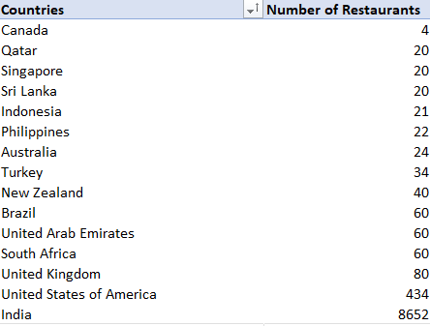
Insight:
In this Pivot Table, Countries with high restaurant counts indicate mature and established markets while countries with low restaurant counts suggest growth potential. India stands on the top with 8652 Restaurants, followed by United States of America with 434 restaurants. Other countries like South Africa, United Arab Emirates, Brazil have 60 restaurants each. The total number of restaurants across the world are 9551.

7)Also, the management wants to look at the number of restaurants opened each year, so provide them with something here.
Ans:

Approach:
- Create Pivot table to count restaurant openings per year and visualize using a line chart to observe trends over time.

Pivot Table:
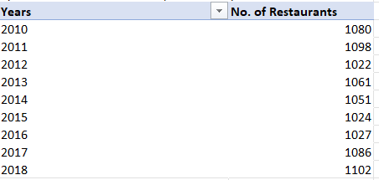

Visualization by Line chart:
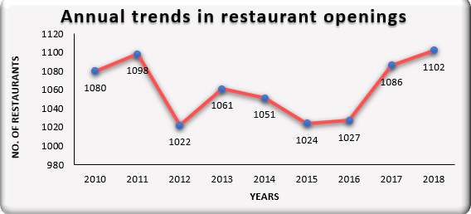
Insights:
The line chart Identifies peaks and slowdowns in restaurant expansion.
- Growth Peaks: Significant growth was observed in 2011 (1,098) and 2018 (1,102), indicating strong expansion years.
- Slowdown Periods: Notable slowdowns occurred in 2012 (1,022) and 2015 (1,024), reflecting temporary market stagnation.
- Positive Momentum: A consistent increase from 2016 to 2018 highlights strong market momentum and growing demand.
- Overall Stability: Despite minor fluctuations, the overall trend demonstrates market resilience and sustained growth in the restaurant industry.

8)What is the total number of restaurants in India in the price range of 4?
Ans:388,
Approach:
Use Formula “=COUNTIFS('Raw Data'!N:N,4,'Raw Data'!D:D,"India")”
Insight:
Only 388 restaurants out of 8652 in India fall into highest price range which indicates rare
demand for premium dining experiences.

9)What is the average number of voters for the restaurants in each country according to the data?
Ans:
Approach:
Use pivot table to calculate average votes per restaurant by country and visualize using a clustered bar chart, highlighting the popularity and engagement levels across regions.

Pivot Table:
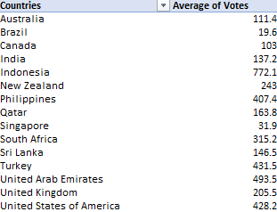

Visualization:
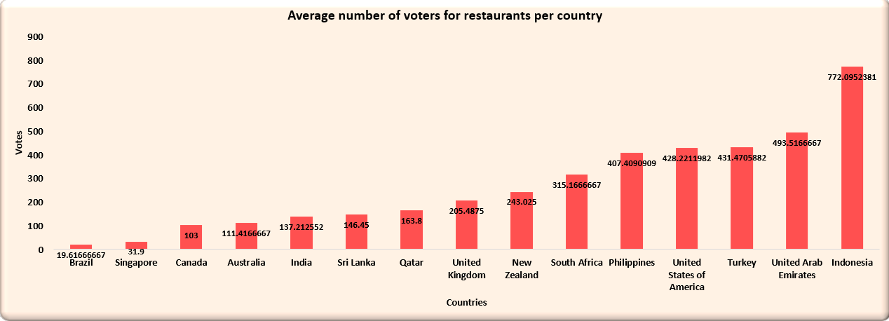
Observation:
- Higher vote counts indicate strong customer engagement and brand recognition while lower votes suggests a lack of awareness or poor service.

- High Engagement: Countries like Indonesia (772.09), UAE (493.5), Turkey (431.4), Philippines (407.4), and USA (428.2) exhibit the highest average voter counts, indicating strong customer participation and popularity.
- Low Engagement: Countries like Brazil (19.6), Singapore (31.9), and Canada (103) show significantly lower voter counts, suggesting either low customer awareness or less active participation in reviews.
- Moderate Engagement with Potential for Improvement: Countries like India (137.2), Sri Lanka (146.4), and Australia (111.4) show moderate engagement but could benefit from increased visibility and customer interaction, leading to potential growth in customer participation.

10)Calculate the average rating for all the restaurants that have price_range < 4 and provide online delivery. Use only the “IF” function, Logical Operators, and Aggregation functions to solve this problem. [Note: Don’t use Conditional aggregation in this question.]
Ans:
Approach:
Use formula: “=AVERAGE(IF(('Raw Data'!N:N<4)*('Raw Data'!K:K="Yes"), 'Raw Data'!Q:Q))”
Insight:
Average rating is 3.27, indicating moderate customer satisfaction with online deliveries.

11)Using Conditional formatting highlight the rows of restaurants that are located in the countries or cities that you’ve suggested to the management for opening new restaurants.
Ans:
Approach:
- Use a pivot table to list countries against aggregates of no of restaurants,their average rating and average of average cost for two.
- Identify and remove outliers from all respective columns of countries’s restaurants, India and Unites States are outliers to data.
- Locate the lowest average ratings of all countries’s restaurants.
- Identify the budget(average of average_cost_for_two) that could appeal to any segment,i.e premium or low budgeted individuals.
Table :

Table with highlighted countries citing lowest average of average_cost_for_two, lowest Number of restaurants, and lowest Average of rating,citing a balance between all these three.

- Countries are:
Canada, Australia, Turkey, Indonesia, Sri Lanka.(highlighted in faint red in above table).
- Conditional Formatting: go to “New Rule” button and go to “Use a rule to determine which cells to format” tab and write the below formula for highlighting entire rows with suggested countries.
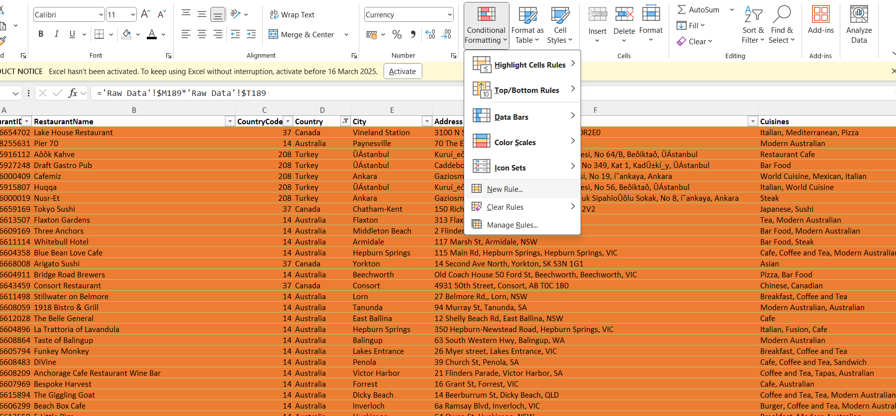

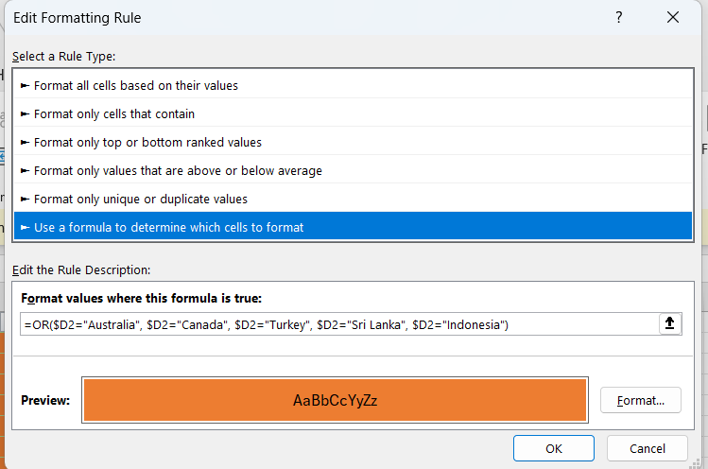
- Formula used “=OR($D2="Australia", $D2="Canada", $D2="Turkey", $D2="Sri Lanka", $D2="Indonesia")”

Insights:
Countries indicated with balance of least number of restaurants, least average_price of two,least ratings are (Canada, Australia, Turkey, Indonesia, Sri Lanka.) are colored as orange in Raw_data table.

12)Create a new customized price column that consists of the abbreviation/symbol of the currency along with the Average_cost_for_two value. [Use string operations to do this task]
Approach:
Using Text function “concatenate” with currency and average cost of two column, establish a new column called “Price”.
Formula used:
=CONCATENATE(MID(I2, FIND("(", I2) + 1, FIND(")", I2) - FIND("(", I2) - 1),"",P2)
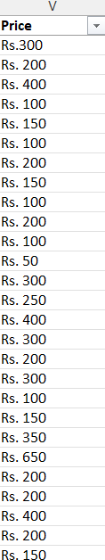

Insight:
Standardizes price representation across currencies.

13)How can you create an array formula in Excel or Google Sheets to count the number of restaurants listed that do not offer online delivery, are in the lowest price range, and have an average cost for two people less than or equal to 250 Indian Rupees?
Ans:1694
Approach:
Formula Used: “=COUNTIFS('Raw Data'!J:J,"No",'Raw Data'!K:K,"1",'Raw Data'!U:U,"<=250")")”

Insight:
1694 restaurants fit the criteria. It indicates a large number of budget-friendly restaurants do not offer online delivery, which further indicates strong offline customer base.

Subjective Question:

1)Suggest a few countries where the team can open newer restaurants with lesser competition. Which visualization/technique will you use here to justify the suggestions?
Ans:
Approach:
Use Pivot Table to examine distribution of restaurants by country.
Sorting data in ascending order of No. of restaurants to identify least competitive markets.
Use a clustered bar chart to display distribution of restaurants across countries.
Extract top 5 countries and make another table ,with fewest restaurants as potential locations for expansion.

Table below:
Pivot table extracted countries table (least competitive)

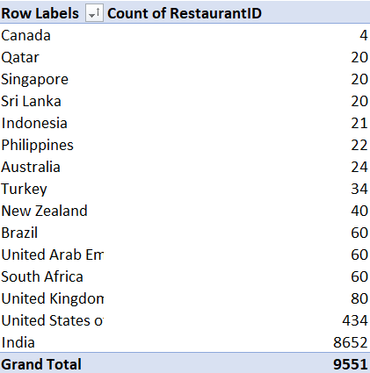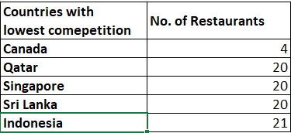

Visualization:
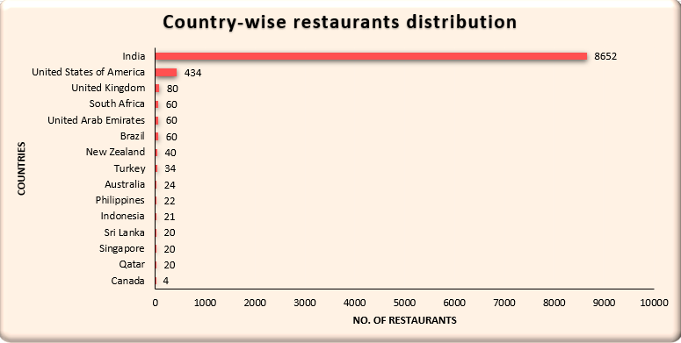

Insights:
- Low-Density Markets: Countries like Canada (4), Qatar (20), and Sri Lanka (20), along with Indonesia, Philippines, and Australia, have significantly fewer restaurants, indicating low market competition and high potential for new restaurant ventures.
- Highly Competitive Markets: Countries like India (8,652) and the United States (434) have a high concentration of restaurants, suggesting intense market competition and potential market saturation, making it challenging for new entrants to stand out.
- Countries with fewer existing restaurants are better suited for expansion as they face lower competition thus having better expansion potential.

Recommendation:
- Consider expanding in countries in following extracted countries as they have higher expansion potential, being least competitive:
- Canada
- Qatar
- Singapore
- Sri Lanka
- Indonesia
- Pilot with less capital first to check for any variables and avoiding losses.

2)Come up with the names of States and cities in the suggested countries suitable for opening restaurants.
Ans:
Approach:
- Use Pivot Table to aggregate number of restaurants on basis of city.
- Filter out the cities based on the suggested countries identified with least competition.
- Identify cities with least competition. sort the pivot Table in ascending order of no. of restaurants .
- While identifying least competitive cities, make sure to not disregard those cities which are only one in their country with restaurant.
- Use clustered Column chart ,we achieve the visual representation of cities with least competition.

Tables below:
Pivot Table Extracted cities table
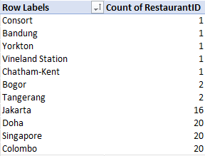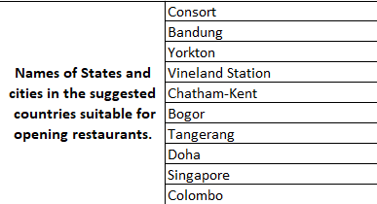

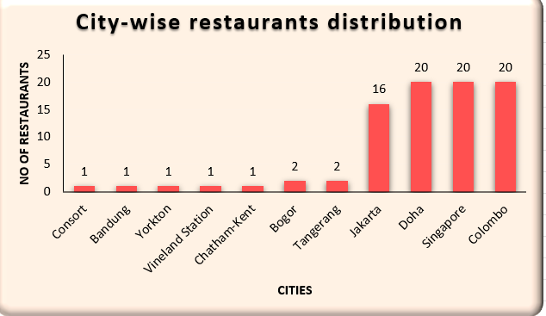

Insights:
Cities with rising populations but fewer restaurants provide strong opportunities.
Recommendation:
Focus expansion on under-represented cities within the extracted cities table(least competitive).
Avoid expansion in city Jakarta, as there are 16 restaurants and there is another less competitive city in Indonesia, but expand in restaurant per single city per country like Doha, Singapore, Colombo.

3)According to the countries you suggested, what is the current quality regarding ratings for restaurants that are open there?
Ans:
Approach:
- Use Pivot Table to calculate average rating for countries.
- Filter restaurant ratings for suggested countries(least competitive countries).
- Use clustered column chart, we could easily compare the location based ratings of least competitive states globally.

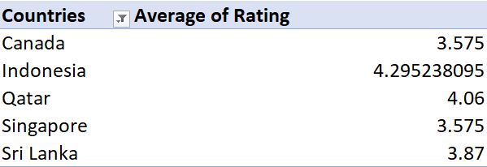
Insights:

- High-Rated Countries:
- Indonesia (4.29), Qatar (4.06), and Sri Lanka (3.87) demonstrate strong customer satisfaction, indicating high service quality and good dining experiences.

- Lower Rated Countries:
- Canada (3.575) and Singapore (3.575) show average or poor customer satisfaction, suggesting inconsistencies in service or food quality.

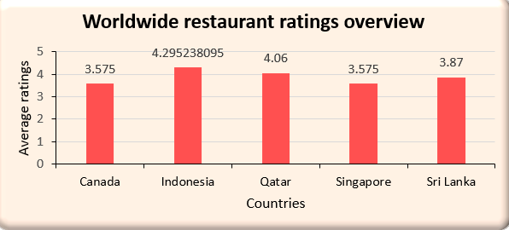

Recommendations:

- For High-Rated Countries:
- Leverage positive ratings for tourism marketing, promoting these countries as premium dining destinations.
- Maintain service and food quality to sustain high customer satisfaction.
- For Lower Rated Countries:
  - Focus on improving service consistency and food quality to enhance customer experience.
  - Analyze customer feedback to identify and address recurring issues.

4)Also, what is the current expenditure on food in the suggested countries, so we can keep our financial expenditure in control?
Ans:
Approach:
- In main raw_data table,
- Create two columns for common currency conversion in Raw_data table:
- 1st one, currency factor for INR named, “CONVERSION FACTOR”.
- 2nd, currency converted to INR named, “AVERAGE_COST_OF_TWO(INR)”.
- Use a pivot table to calculate total “AVERAGE_COST_OF_TWO(INR)” per country.
- Use clustered bar chart,for identifying the expenditure in these countries.

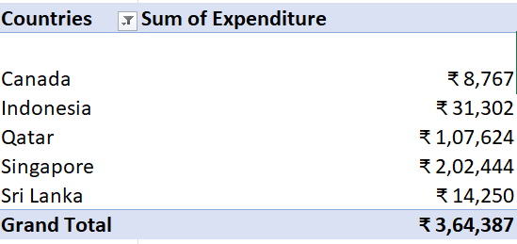

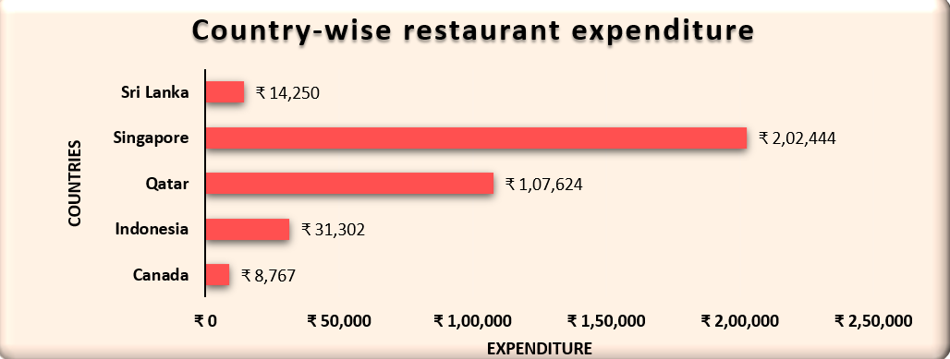
Insights:
- Singapore (₹2,02,444) and Qatar (₹1,07,624) have the highest restaurant expenditures, indicating high spending power and demand for premium dining experiences.
- Indonesia (₹31,302) and Sri Lanka (₹14,250) show moderate spending, suggesting potential for growth in mid-range dining options.
- Canada (₹8,767) has an extremely low expenditure, possibly indicating a lack of restaurant market presence or data collection gaps.

Recommendations:
- Menu and pricing strategy: Singapore and Qatar show high spending potential, making them ideal targets for luxury and fine-dining investments.
- Optimize Expansion Budget: Indonesia and Sri Lanka could benefit from affordable dining options and marketing strategies to boost spending.

5)Come up with the names of restaurants from the recommended states that are our biggest competitors and also those that are rated in the lower brackets, i.e. 1-2 or 2-3.
Ans:
Approach:
- Use a pivot table to calculate average rating of every restaurant.
- Filter the restaurants by suggested cities
- Sort them in descending order by Avg. Rating to find biggest competitor.

Insights:
- High-Rated Competitors:
Ministry of Crab, Talaga Sampireun, Mainland China Restaurant are our biggest competitors indicated by their highest rating of 4.9 and dominate the premium restaurant space.
- Low rated restaurants:
Queen's Café rated with 2.5 and Elite Indian Restaurant rated with 2.4 are among most poor rated restaurants in suggestive cities, indicating a potential opportunity to introduce high-quality options.
- Majority of Restaurants Have Ratings Between 3.5 and 4.2: Most restaurants fall within the 3.5 to 4.2 rating range, suggesting that while they offer decent quality, they may lack the unique qualities needed to achieve ratings above 4.5.
Pivot table: Restaurants with rating under “3”
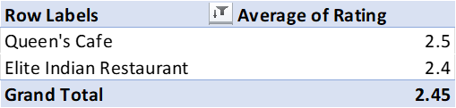

Recommendations:
- Low rated restaurants (Queen’s Café,Elite Indian Restaurant) should prioritize improving menu offerings, customer experience, and staff training to elevate their ratings.

- Establishments within 3.5-4.2 range should introduce unique dishes, enhance ambiance, or offer special promotions to improve their rankings and compete with top-tier competitors.

6)Which cuisines should we focus on in the newer restaurants to get better feedback? Does the choice of cuisines affect the restaurant ratings?
Ans: Yes, the choice of cuisines does affect restaurant ratings. To get better feedback in newer restaurants, focus on high-performing cuisines such as International, Indian, and fusion cuisines as they consistently receive higher ratings throughout latest 3 year trends.
Approach:
- Use Pivot Table and aggregate average of rating against every Cuisine.
- Use filter by city to contain only the suggested cities.
- Use filter by year to identify last 3 year’s trends and how people rated restaurants according to most recent trends.
- Filter the dataset to extract only top 10 rated Cuisines.
- Utilize clustered bar chart for Cuisine’s respective ratings(avg).
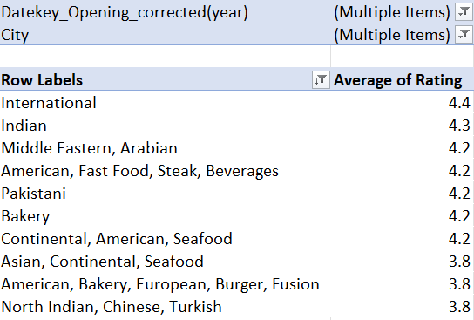

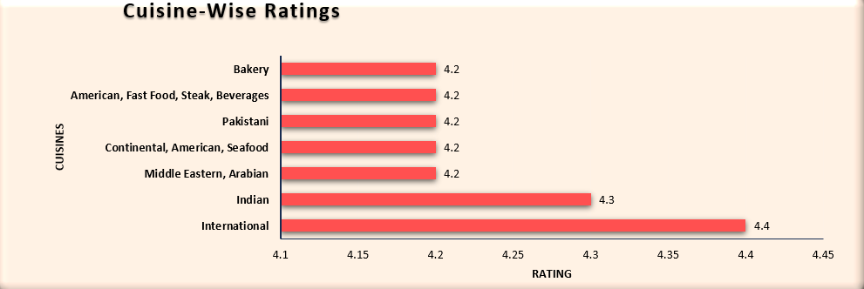

Insights:
- Dominant Cuisines: International and Indian cuisines consistently receive high customer satisfaction, with ratings of 4+, reflecting strong customer preference.
- Preference-Driven Demand: High-rated cuisines like International attract a broad customer base, while regional cuisines (e.g., North Indian in India) cater to local preferences, emphasizing the need for menu localization.
Recommendations:
- Expand High-Rated Cuisines: Open more outlets specializing in International and Indian cuisines, especially in new locations, to increase customer engagement and boost ratings.
- Local Adaptation: Customize the menu based on regional preferences to attract local customers who may favor native dishes over global cuisines.
- Menu Optimization: Regularly update the menu based on customer feedback and ratings.
- Seasonal Offerings: Introduce seasonal or limited-time dishes aligned with emerging food trends to keep customer interest high and enhance dining experiences.
- Refine or remove low-rated cuisines to maintain high overall restaurant ratings.

7)According to our current data, should we go for online delivery and table booking? Does that affect the customer’s ratings?
Ans:

Approach:
- Use two Pivot Table to calculate Online booking avg. ratings and Table booking avg. ratings across all restaurants respectively.

Table:

Visualization:
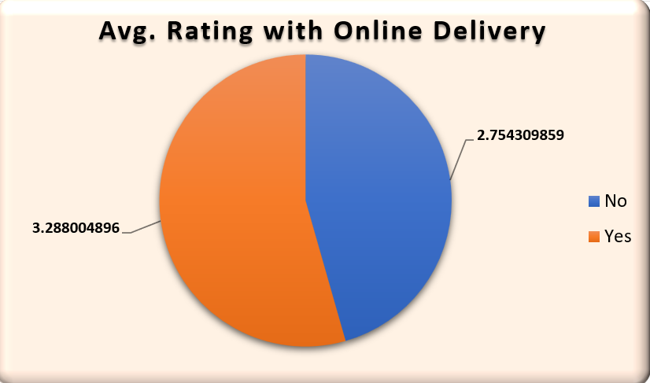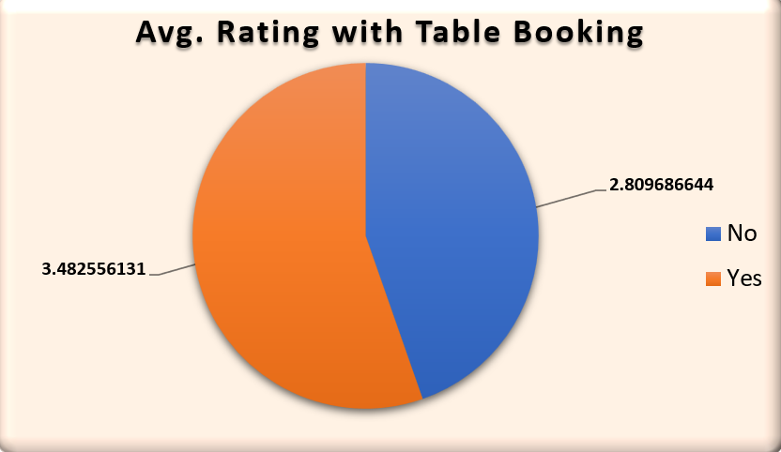

Insight:

Restaurants offering online delivery have an average rating of 3.288, compared to 2.754 for those without. Similarly, restaurants with table booking have a higher average rating of 3.482 compared to 2.809 without it. This indicates that providing these services significantly enhances customer satisfaction.

Recommendation:

- Implement Online Delivery and Table Booking: Expand these services across all locations to boost customer ratings and satisfaction.
- Enhance Service Experience: Focus on delivering a seamless user experience through efficient delivery systems, easy booking processes, and high-quality service to maximize positive customer feedback.

8)Should the team keep the rate of cuisines higher? Will that affect the feedback? According to our data are the rates of cuisines and ratings, correlated?
Ans:
Approach:
Use Excel's CORREL function to analyze the correlation between cuisine price and ratings.

Use formula: “=CORREL('Raw Data'!P:P,'Raw Data'!Q:Q)”

Insight:

A correlation of 0.06 indicates almost no relationship between cuisine pricing and customer ratings. This suggests that price adjustments have minimal impact on customer feedback, as ratings are driven more by service quality and dining experience rather than pricing.



Recommendation:
Keep competitive pricing without unnecessarily increasing rates.
Improve food quality and service rather than just adjusting prices.
Experiment with dynamic pricing for peak and non-peak hours.
Offer loyalty programs to retain customers without affecting price sensitivity.

9)What is the distribution of the number of restaurants of different price ranges in all the countries?
Ans:
Approach:
Use a pivot table to group restaurants by price range and country.
Visualize using a clustered column chart.

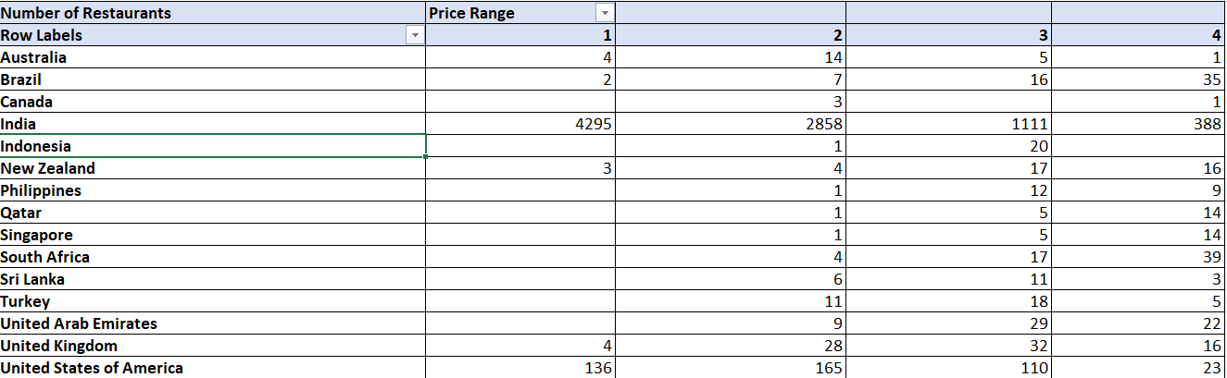

Visualization:
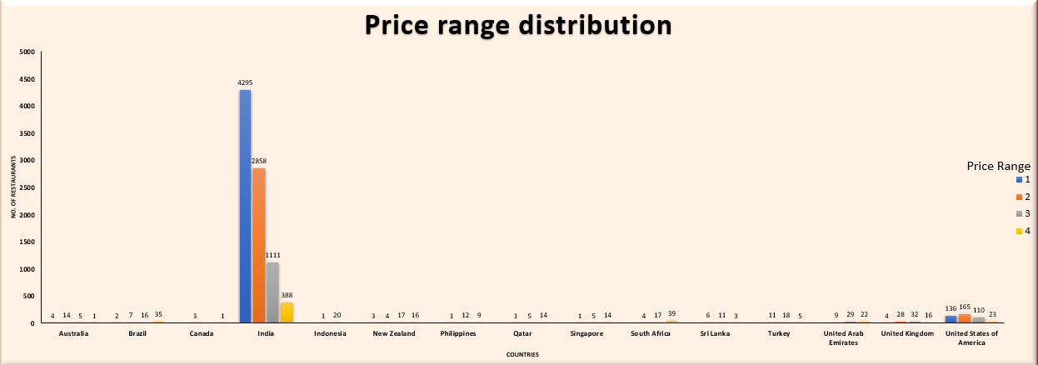

Insights:

- India dominates the restaurant landscape, with a majority of outlets falling under lower price ranges (1 & 2), reflecting a strong demand for affordable dining options.
- In developed countries such as the U.S., U.K., and Australia, there is a balanced distribution across all price ranges, indicating diverse consumer preferences for both budget-friendly and premium dining experiences.
- Premium dining markets are more prominent in Brazil and South Africa, where a higher number of upscale restaurants (Price Range 4) suggests a strong appetite for fine dining.
- Limited market size is observed in countries like Canada and Indonesia, where the restaurant count remains comparatively low, presenting potential for market expansion.

Recommendations:

- Target budget-conscious customers in India and other high-demand markets by expanding affordable dining options, catering to price-sensitive consumers.
- In developed countries, such as the U.S., U.K., and Australia, adopt a balanced approach by offering both casual and premium dining experiences to address varied customer preferences.
- Capitalize on high-end dining demand in markets like Brazil, South Africa, and Qatar by expanding fine-dining establishments, leveraging the existing appetite for premium experiences.

10)Explain your approach in brief for suggesting countries/cities in order to open new restaurants, if the objective and subjective questions would have not been given to assist you.
Ans:
Approach:
- Identify countries/cities with least number of restaurants so to avoid any competition.
- Cities with higher demand of online deliveries than table booking indicate people shifting towards digital mode and avoiding table booking.
- Identify cities with low average ratings, citing demand for better options, Filter the data to include only countries with an average rating below 4, indicating areas with potential for higher-quality restaurant establishments.
- Focus on locations with high votes and reviews, indicating strong customer interest and activity.

